

Sugarmill Woods Crime Watch

Operations Reference Manual



January 20, 2010
(Includes Amendment #1, July 2012)
RECORD OF AMENDMENTS

NUMBER DATE

1 July 2012
AUTHORIZATION

This Operations Reference Manual is intended for the use of the Sugarmill Woods Crime Watch (SMWCW) of Citrus County, Florida. The SMWCW organization is authorized by and operates under the authority of the Citrus County Florida Sheriff’s Office (CCSO), Inverness, Florida.

This Operations Reference Manual was developed in accordance with existing CCSO and SMWCW directives, as follows:

- CCSO “Volunteer Unit Rules & Procedures Handbook”
- Sugarmill Woods Crime Watch “By-Laws”
- Sugarmill Woods Crime Watch “Training Outline”

Other Crime Watch organizations wishing to use this manual will direct their request to the President, Sugarmill Woods Crime Watch, Homosassa, FL 34446. The current President of the Sugarmill Woods Crime Watch can be determined by contacting the Citrus County Sheriff’s Office, Volunteer Unit.

/s/
RICHARD L. BYRNES
President
Sugarmill Woods Crime Watch
Homosassa, Florida

TABLE OF CONTENTS

SECTION / TITLE PAGE NUMBER

I. MISSION OF THE SUGARMILL WOODS CRIME WATCH……………1

- General
- Crime Watch Duties vs. Property Owner Association Rules

II. GENERAL RULES & REQUIREMENTS FOR VOLUNTEERS………....1-2

- Guidance, Information or Complaints Regarding the
Sugarmill Woods Crime Watch
- Confidentiality Responsibility
- Act Professionally at All Times
- Alcohol / Drugs
- Political Discussions or Ideals
- Official Position of the Citrus County Sheriff’s Office
- Private Gain
- Accepting Gifts
- Arrest or Detention Authority
- Carrying Firearms or Weapons

III. WEARING THE UNIFORM…………………………………………….…3-4

- Wear it Proudly
- For Official Use Only
- ID Badges / Other Items
- Baseball Cap
- Trousers, Shorts & Shoes
- Uniform Shirts
- Uniform Trousers / Shorts
- Other Uniform Items
- Entering Taverns, Bars or the Like

IV. PATROL CAR…………………………………………………….…….…..4-8

- For Official Business Only
- Seat Belts
- Unattended Vehicle
TABLE OF CONTENTS
(Continued)

SECTION / TITLE PAGE NUMBER

IV. PATROL CAR…………………………………………………….…….…..4-8
(Continued)

- Flashing Yellow Lights
- Alcohol / Drugs
- Eating or Drinking
- Sleeping
- Passengers
- Traffic Accident or Injury
- Forms Used to Report Mechanical Problems with the Patrol Car
- First Driver of the Day Responsibilities
- Subsequent Driver of the Day Responsibilities
- When the Sheriff’s Maintenance Garage is Closed
- Refueling the Patrol Car

V. TRAFFIC LAWS…………………………………………………….….…..8

- General
- Speed

VI. SCHEDULING OF HOURS……………………………………….......……8

- Number of Hours Worked
- Operating Hours

VII. ASSIGNED TOURS………………………………………………….……..9

- 5 Distinct Areas (Tours)
- Tours are Random
- Crime Mapping
- Sheriff can Redirect
TABLE OF CONTENTS
(Continued)

SECTION / TITLE PAGE NUMBER

VIII. RADIOS (IN-CAR & HANDHELD)………………………………….……9-11

- For Official Purposes Only
- Be in Radio Contact Always
- Both Radios on Same Frequency
- Patrol Car Radio – You Must Physically Turn OFF
- Handheld Radio
- Call Signs
- A Brief Pause When Transmitting
- Use Plain Talk on the Radio
- Phonetic Alphabet
- Reporting IN or OUT of SERVICE
- “10-4” Status Check
- Presumed to be in Trouble -- IMPORTANT

IX. CONDUCTING HOUSE CHECKS…………….…………………….……..11-13

- How to Request a House Check
- Lead Time
- Determining the House Checks for Your Tour
- Read the House Check Form CAREFULLY
- House Check: Walk-Around or Drive-By
- Always Use CAUTION and DISCRETION
- Documenting the House Check

X. NEW CONSTRUCTION SITES & INFRASTRUCTURES
INSPECTIONS………………………………………….…..….…….14-15

- Drive-By’s Only
- Construction Sites
- Infrastructures
- Always Use CAUTION and DISCRETION
- Documenting the New Construction / Infrastructure Inspection

TABLE OF CONTENTS
(Continued)

SECTION / TITLE PAGE NUMBER

XI. DOCUMENTS & PROCEDURES…………………………………….……15

- Daily Vehicle Log

ATTACHMENTS:

- Uniform Badge / Insignia Placement………………………………..…….....16
- CCSO Crime Mapping……………………………………………………….17-18
- Phonetic Alphabet……………………….………………………….….….…19

- MISSION
OF THE SUGARMILL WOODS CRIME WATCH

- General: To assist Citrus County law enforcement officials in dealing more effectively with combating crime, by:

- Making our Crime Watch vehicle as visible as possible in our community

- Providing additional “eyes & ears” for the Sheriff’s Office

- Looking for and reporting criminal or suspicious activities

- Conducting house checks

- Conducting checks of construction sites and infrastructures

- Reporting missing or damaged street signs

- Performing any other support, as requested by the Sheriff’s Office

- Crime Watch Duties vs. Property Owner Association Rules: Do not confuse Crime Watch duties with those of any property owner association -- Crime Watch volunteers do not enforce association code violations. Any exception to this policy may only be authorized by the President, Sugarmill Woods Crime Watch.

- GENERAL RULES & REQUIREMENTS
FOR VOLUNTEERS

- Guidance, Information or Complaints Regarding the Sugarmill Woods Crime Watch: Should you ever have questions, comments, or complaints regarding any SUGARMILL WOODS Crime Watch matter contact the Lieutenant or Sergeant assigned to your specific duty day. You may also direct your questions or comments to the Sugarmill Woods Crime Watch Captain or President. Another source is the Sugarmill Woods Crime Watch’s website: www.smwcw.org. (Obtain the User Name & Password for the website from any of the above individuals). Finally, you may contact SGT Evan, CCSO Community Volunteer Program. Non Crime Watch members may also direct their questions, comments or complaints to any of the above named individuals – SMWCW members will provide the necessary contact information.
- GENERAL RULES & REQUIREMENTS
FOR VOLUNTEERS
(Continued)

- Confidentiality Responsibility: In performing Crime Watch duties, volunteers might be exposed to information of a sensitive law enforcement nature or of a privacy nature. Such information is considered strictly confidential and may only be discussed with officials of the Citrus County Sheriff’s Office and/or Sugarmill Woods Crime Watch officials.

- Act Professionally at all Times: As a representative of the Citrus County Sheriff’s Office you are obligated to act professionally at all times when you are in uniform or in the patrol car.

- Alcohol / Drugs: Neither alcohol nor drugs may be consumed by Sugarmill Woods Crime Watch volunteers while they are in uniform or in the patrol car.
Also see Section IV below, Patrol Car, regarding the use of prescription drugs and also the minimum 8-hour time limit required before driving, after having consumed alcohol.

- Political Discussions or Ideals: Discussions of a political nature are strictly prohibited while in uniform or on duty. However, nothing prohibits a member from involving themselves in political activities or opinions while off duty or not in uniform.

- Official Position of the Citrus County Sheriff’s Office (CCSO): Sugarmill Woods Crime Watch (SMWCW) volunteers may never express an official position of the CCSO or SMWCW. Public statements pertaining to the CCSO or SMWCW may only be made by officials from those organizations.

- Private Gain: Using any information obtained in connection with your volunteer status for private gain is strictly prohibited.

- Accepting Gifts: Accepting gifts, favors or services that may reflect improper influence in the discharge of official Citrus County Sheriff’s Office or Sugarmill Woods Crime Watch duties is not allowed. Refer to Section 7, General Rules & Procedures, CCSO Volunteer Unit Rules & Procedures Handbook for further guidance.

- Arrest or Detention Authority / Citizens Arrest: Sugarmill Woods Crime Watch volunteers have NO arrest or detention authority. Further, “Citizens Arrest” does not exist under Florida law.

- Carrying Firearms or Weapons: No firearms or weapons of any kind may be carried while on duty with the Sugarmill Woods Crime Watch – even if the Crime Watch volunteer possesses a valid concealed weapons permit. A pocketknife can be carried as long as it is in a pants pocket or case on the belt, but Bowie or boot-type knives are prohibited.
III. WEARING THE UNIFORM

- Wear it Proudly: Wear your uniform proudly and ensure that it is kept clean. Make sure that your shirt is neatly tucked into your trousers or shorts at all times.

- For Official Use Only: Never conduct personal business while in uniform. The uniform is to be used for official business only. The same applies for the patrol car (see Patrol Car, Section IV below).

- Your uniform may only be worn for official purposes, for example, while on duty or to attend an official Crime Watch meeting or function. You MUST wear your uniform when driving the patrol car EXCEPT in two instances:

- When the patrol car is being turned over to you at the end of the last tour of the day for your tour starting the next day;

- If you are transporting the vehicle to the Sheriff’s Maintenance Garage and not otherwise on duty at that time.

- ID Badges / Other Items: The ID badge will be clipped to the inside right pocket of the uniform shirt. The ID badge is the property of the Citrus County Sheriff’s Office and must be returned whenever a volunteer no longer performs duties for the CCSO. (See ATTACHMENT 1 regarding the placement of other items on the uniform (excerpt from Section 6, Uniforms, CCSO Volunteer Unit Rules & Procedures Handbook)).

- Baseball Cap: Only the “Sheriff’s Volunteer” or “Sugarmill Woods Crime Watch” baseball cap may be worn (or not) at the individual’s discretion.

- Trousers, Shorts & Shoes: Pants or shorts in black, green, navy or khaki may be worn with the uniform shirt. Any comfortable shoes or sneakers may be worn.

- Uniform Shirts: The Sugarmill Woods Crime Watch purchases uniform shirts and issues one to each of its volunteers. These shirts are the property of the Sugarmill Woods Crime Watch and must be returned whenever a volunteer no longer performs duties for the Sugarmill Woods Crime Watch.

- Uniform Trousers / Shorts: Some Sugarmill Woods Crime Watch members might be issued uniform pants or shorts. When issued, these items are also the property of the Sugarmill Woods Crime Watch and must be returned whenever a volunteer no longer performs duties for the Sugarmill Woods Crime Watch.

III. WEARING THE UNIFORM
(Continued)

- Other Uniform Items: Additional uniform items, such as jackets, badges, etc., may be purchased by individual volunteers and would become that person’s
property. Contact the President, Sugarmill Woods Crime Watch, for further information on ordering additional uniform items.

- Entering Taverns, Bars or the Like: Entering taverns, bars or businesses that primarily sell alcohol is strictly prohibited while in uniform or on duty.

IV. PATROL CAR

- For Official Business Only: The patrol car is to be used for official business only. Do not conduct personal business in the patrol car (or whenever in uniform).

- Seat Belts: EVERY person in the Sugarmill Woods Crime Watch patrol car must wear a seat belt – driver and passengers -- front and back seats.

- Unattended Vehicle: NEVER leave the patrol car running while unattended. Always remove the keys and lock the vehicle when it is unattended.

- Flashing Yellow Lights: The flashing yellow lights on the roof of the patrol car are not to be used routinely. They may be used in instances such as assisting at a traffic crash or other incident when their use would enhance safety.

- Alcohol / Drugs: Neither alcohol nor drugs may be consumed by Sugarmill Woods Crime Watch volunteers while they are in uniform or in the patrol car.

- Consuming Alcohol: There is a minimum 8-hour time period that must
pass between any Crime Watch driver’s use of alcoholic beverages and
his/her driving of the patrol car.

- Prescription Drugs: If taking prescription drugs, contact your doctor if there is any question as to whether or not the prescription drug(s) could interfere with the safe operation of the patrol car.

- Eating or Drinking: In general, eating or drinking is not allowed in the patrol car; however, chewing gum or drinking bottled water is permitted. Please remove all trash from the vehicle when you leave.

- Sleeping: Sleeping is never permitted in the patrol car; either by the driver or passenger(s). Although this might seem silly, there have been times, when because of mileage restrictions, we were forced to park the patrol car on the side of the road during shifts to stay within mileage limitations.
IV. PATROL CAR
(Continued)

- Passengers: Only Crime Watch or Citrus County Sheriff’s Office personnel are allowed to drive or be a passenger in the patrol car. Any exceptions must be directed by or approved by Citrus Dispatch.

- Traffic Accident or Injury: If you are involved in a traffic accident in the patrol car, whether there is damage, injury, or not, you must:

  - Immediately notify Citrus Dispatch on your radio with the details.
  - Notify your Lieutenant or Sergeant as soon as possible.
  - Ensure your LT, SGT or yourself notify the Sugarmill Woods Crime
Watch Captain and President as soon as possible.
  - Record the details and your actions taken in the Daily Log located in the patrol car.

- Forms Used to Report Mechanical Problems with the Patrol Car: The Vehicle Trouble Report Form must be filled out whenever the patrol car is taken to the Sheriff’s Maintenance Garage for service. Otherwise, use the Vehicle’s Daily Log to report matters of a mechanical nature. Both of these forms are located in the patrol car.

- First Driver of the Day Responsibilities:

- Contact Appropriate CCSO Duty Detective: Call Citrus Dispatch by radio and advise them that you are the first driver of the day for Sugarmill Woods. Ask for the name of the “Duty Detective” for Sugarmill Woods. Upon receiving the name & telephone number, attempt to contact that individual by telephone to determine if there are any special instructions for the day. If appropriate, make a notation on the driver’s log to alert subsequent drivers. If the duty detective does not answer or return your call you are not required to make multiple attempts.

- Vehicle Safety Checklist:

  - First Driver of the Day duties actually begin the day before, when you take ownership of the vehicle from the previous day’s driver. Refer to the first section of the Vehicle Safety Checklist (reverse side of the Daily Log) regarding notification to Citrus Dispatch that you are “out of service” and instructions for removing certain equipment from the patrol car.

  - Do a Walk-Around Inspection of the patrol car looking for body damage, improper tire inflation, proper operation of the lights, etc.

IV. PATROL CAR
(Continued)

  - Do an Under-The-Hood Check of the patrol car looking for fluid leaks and checking fluid levels.

  - Check the Trunk of the patrol car to ensure that all equipment listed on the Vehicle Safety Checklist is in fact accounted for.

- Subsequent Driver of the Day Responsibilities: Upon turn-over of the patrol car to you by the preceding driver, note the condition of the tire pressure and check the vehicle for any noticeable body damage; take corrective action as delineated below.

- Corrective Actions:

- Whenever any corrective action is taken on the patrol car that results in its being taken out of operation from regular patrol duties, notify your Lieutenant, Sergeant or the Sugarmill Woods Crime Watch President/Captain immediately.

- Body Damage: Document any new body damage on the patrol car’s Daily Vehicle Log and notify your Lieutenant or Sergeant immediately. NOTE: Unless the damage occurred overnight, it should have been noticed/reported at vehicle turnover the previous day.

- Tire Pressure: If tire(s) require air, you can inflate them yourself or take the vehicle to a service station. If a flat tire, you can change it or call the Citrus County Sheriff’s Office (CCSO) Maintenance Garage for assistance (341-7485); also notify your Lieutenant, Sergeant or the Sugarmill Woods Crime Watch Captain or President and annotate the Daily Vehicle Log. If you are required to take the vehicle to the Sheriff’s Maintenance Garage for resolution, the Vehicle Trouble Report form must be completed.

- Fluids: If you spot leaking fluids, use your discretion in operating the patrol car or calling the Sheriff’s Maintenance Garage for guidance. You may only add those fluids to the car that are located in the vehicle’s trunk. Document any irregularity on the Daily Vehicle Log. If you are required to take the vehicle to the Sheriff’s Maintenance Garage for resolution, the Vehicle Trouble Report Form must be completed.

- Lights: If the headlights, turn signals, brake lights or yellow flashing roof lights are inoperable, take the vehicle to the Sheriff’s Maintenance Garage for resolution (or) call the Sheriff’s Maintenance Garage for guidance. The Vehicle Trouble Report form must be completed if the Sheriff’s Maintenance Garage performs any work on the vehicle.
IV. PATROL CAR
(Continued)

- When the Sheriff’s Maintenance Garage is Closed: Should a mechanical problem occur with the patrol car during hours when the Sheriff’s Maintenance Garage is closed, contact Citrus Dispatch and request their guidance in resolving the matter. Also notify your Lieutenant, Sergeant and/or the Sugarmill Woods Crime Watch Captain or President as in the instances above.

- Refueling The Patrol Car:

- When to refuel: You are required to refuel the patrol car when the gas gauge approaches the ½ tank mark.

- Where to refuel: Typically, we use one of the 2 gas stations on Route 19 that are closest to Sugarmill Woods (Cumberland Farms or Circle K). However, the credit card we use SHOULD be valid at any gas station within Citrus County.

- Which fuel to use: Always use the least expensive (87 octane) fuel.

- How to refuel:

- Swipe the credit card at the pump and watch the pump’s screen for further prompts.

- When prompted for the Driver’s or PIN Code, enter the code listed on the canvas divider in the log book that’s in the patrol car.

- When prompted for the vehicle’s mileage, enter the mileage (do not enter 10ths of a mile – if 5/10ths or more, round up to the next mile)

- Obtain receipt from the pump showing total cost, mileage and gallons; place in the vehicle’s log book after annotating the Daily Vehicle Log accordingly.

- IMPORTANT: If no receipt is provided at the pump, obtain a receipt from the cashier showing the information required in the preceding subparagraph above.

- Credit Card / PIN: The credit card to refuel the patrol car is located in a protective pocket attached to the left dash of the vehicle. The Personal Identification Number (PIN), also known as “Drivers Code” is printed on the canvas divider inside the log book/binder in the patrol car.

IV. PATROL CAR
(Continued)

- Refueling Loaner Patrol Cars: Credit cards are issued for each specific patrol car. While using a loaner patrol car, perhaps while ours is being serviced, DO NOT SWITCH CREDIT CARDS – use the card assigned to that vehicle.

V. TRAFFIC LAWS

- General:

  - Always come to a complete stop at stop signs.

  - Use turn signals at all times.

  - Always be courteous to pedestrians and other traffic.

  - All federal, state and local laws apply. Driving the patrol car DOES NOT give Crime Watch volunteers any special privilege or exception to federal, state or local laws.

- Speed: Maintain a slow speed, 20 mph generally -- up to the posted speed limits on main thoroughfares.

VI. SCHEDULING OF HOURS

- Number of Hours Worked: Sugarmill Woods Crime Watch volunteers are asked to work a minimum of 5 hours each month, as follows:

- Two shifts of 2 hours each (4 hours total) These are scheduled by the applicable Lieutenant or Sergeant for your assigned day of the week

  - 1 additional hour monthly, to attend the Sugarmill Woods Crime
Watch meeting on the 2d Monday each month, 3 p.m. @ the Sugarmill Woods Country Club (except for June, July & August). Wear the uniform to the meeting, if desired, or appropriate civilian attire -- per Club rules no jeans, denim clothing or non-collared shirts are allowed.

- Operating Hours: Currently the Sugarmill Woods Crime Watch operates Monday through Saturday between the hours of 8:00 a.m. to 6:00 p.m. These days and hours could change if so directed by the Citrus County Sheriff’s Office.
VII. ASSIGNED “TOURS”

- 5 Distinct Areas (Tours): Sugarmill Woods is broken down into 5 distinct areas called “Tours.” There is a laminated map in the patrol car clearly defining the Tour Areas, as follows:

- Tour 1: Oak Village South

- Tour 2: Cypress Village & East Southern Woods

- Tour 3: Cypress Village North

- Tour 4: Oak Village North

- Tour 5: Cypress Village Southwest

- Tours are Random: Tours are scheduled in a random fashion to ensure all 5 Sugarmill Woods areas are checked on a daily basis. Check the monthly schedule to determine the Tour Areas for your shifts.

- Crime Mapping: Sugarmill Woods Crime Watch volunteers who have access to a computer should check the Citrus County Crime Mapping website to determine if there are specific “hot spots” within the community that might suggest increased awareness (see Attachment 2 for instructions on how to access the website).

- Sheriff can Redirect: The Citrus County Sheriff’s Office has the authority to redirect any Crime Watch unit from their assigned tour to another area within the county, as they deem necessary (this rarely happens, however).

VIII. RADIOS (IN-CAR & HANDHELD)

- For Official Purposes Only: Be professional at all times when using the radio. Use the radio only for Official purposes -- Never for personal conversations or business.

- Be in Radio Contact Always: You must be in radio contact with the Citrus County 9-1-1 dispatcher (Citrus Dispatch) at all times while performing Sugarmill Woods Crime Watch duties. See “IMPORTANT” below. Whenever leaving the patrol car, for example, to conduct a house check, you must have the handheld radio on your person (unless you have another Sugarmill Woods Crime Watch person in the patrol car monitoring the radio).

- Both Radios on Same Frequency: Both the in-car radio and the handheld radio are set to the same frequency. This is Crime Watch’s communication frequency with Citrus 9-1-1 Dispatch.
VIII. RADIOS (IN-CAR & HANDHELD)
(Continued)

- Patrol Car Radio – You Must Physically Turn OFF: The in-patrol car radio DOES NOT automatically turn off when the vehicle’s ignition is turned off. Ensure it is physically turned OFF when the vehicle is turned off so as not to drain the battery.

- Handheld Radio: This radio will be turned OFF until it is needed operationally. There is a charger located in the patrol car to recharge the handheld radio. Consult the Log Book in the patrol car for current information regarding when the handheld radio requires charging and which driver is responsible to perform the charging.

- Call Signs: Our Call Sign is “Sugarmill Woods.” Each Crime Watch vehicle in Citrus County has its own distinct call sign. The 9-1-1 dispatcher’s call sign is: “Citrus” or sometimes “Citrus Dispatch.”

- A Brief Pause When Transmitting: When depressing the mic of either the in-car or handheld radio, note that you must pause for a split second before speaking. If you speak immediately the first word or part of the word will likely be cut off.

- Use Plain Talk on the Radio: So called “10 Codes” will not be used by the Sugarmill Woods Crime Watch, even though Citrus Dispatch uses them occasionally. The following are terms that we frequently use:

  - In Service

  - Out of Service

  - Received or Acknowledged

  - Out of Vehicle

  - Etc.

- Phonetic Alphabet: When it becomes necessary, the phonetic alphabet is the preferred method used in spelling out or clarifying a letter. A copy of the phonetic alphabet is located at Attachment 3 at the end of this manual. However, commonly used names are also acceptable, for example: “Apple for A;” “Boy for B;” “Frank for F;” etc.

VIII. RADIOS (IN-CAR & HANDHELD)
(Continued)

- Reporting IN or OUT of Service: The first Sugarmill Woods Crime Watch driver every day will notify Citrus Dispatch that they are “In Service” – “Citrus, this is Sugarmill Woods, In Service.” Conversely, the last driver of the day (usually the individual driving the patrol car to their home for the next day’s first shift) will notify Citrus that they are “Out of Service.” For any number of reasons there could be other times during the day that the patrol car is taken Out of Service – ensure whenever it is taken OUT of Service that it is reported back IN Service, as appropriate.

- “10-4” Status Check: Citrus Dispatch typically requests each Crime Watch’s status once every hour or two --: “Sugarmill Woods, this is Citrus, 10-4 or Status Check.” Your response should be: “Citrus, this is Sugarmill Woods, Clear.” And a new requirement is that you add your location to the status check, for example: “Citrus, this is Sugarmill Woods, Clear; I’m on Paw Paw Ct. South.”

- Presumed to be in Trouble – IMPORTANT !!!!!: A vehicle that is considered to be In Service that cannot be contacted by radio is presumed to be in trouble. This will set off a chain reaction from phone calls to the pertinent Crime Watch’s President; Sheriff’s Deputies being dispatched to look for the vehicle; and possibly the Sheriff’s helicopter being dispatched. If you’re actually in trouble this reaction is comforting; if you’ve simply neglected to report “Out of Service” or didn’t take the handheld radio with you when outside the patrol car, it would be very embarrassing, to say the least.

IX. CONDUCTING HOUSE CHECKS

- How to Request a House Check: Residents of Sugarmill Woods may request that their homes be checked by the Sugarmill Woods Crime Watch during scheduled patrols by calling the Citrus County Sheriff’s Office at 726-1121 or contacting them online at www.sheriffcitrus.org – click on “Crime Prevention” and then on “Vacation Request.”. NOTE: Generally, house checks are more abundant during the summer months while the “snowbirds” are away.

- Lead Time: There is usually about a 2-week lead time from the time the request is made until the completed House Check form is actually posted in the patrol car’s log book.
IX. CONDUCTING HOUSE CHECKS
(Continued)

- Determining the House Checks for Your Tour: Refer to the log book(s) in the patrol car at the beginning of your tour to determine your specific tour number for
the day and the corresponding house checks for that tour. Don’t ever be overwhelmed by the number of house checks for your tour area. The summer months generally produce a higher number of house checks; however, patrolling your assigned tour area takes precedence over conducting house checks. If you did not complete all the house checks in your tour area, that’s okay, just do the best you can.

- Read the House Check Form CAREFULLY: Pay particular attention to the START and END dates. (NOTE: Sometimes the House Check form will be posted in the log book prior to the actual start date or remain in the book a day or two after the end date.) Also pay attention to the exact address – make sure you’re correct in identifying the address as a “street,” “avenue,” “court,” and “north,” “south,” etc as many streets in Sugarmill Woods are almost the same.

- House Check: Walk-Around or Drive-By:

- Walk-Around: The preferred method for conducting house checks is the Walk-Around (W/A). Exactly as implied, the volunteer will walk completely around the home, observing all windows and physically pulling on doors to ensure that they’re both intact and/or secured. Should you encounter anything that looks suspicious, for example: a broken or raised window; an unsecured door; etc; IMMEDIATELY stop your check, return to the patrol car, leave the immediate area and notify Citrus Dispatch. See section below: “Always Use CAUTION and DISCRETION.”

- Drive-By: The drive-by house check would be used in lieu of the walk-around when a situation dictates, for example:

- The driver is alone (no observer in the patrol car) and the handheld radio is inoperable

- The weather is inclement

- The home’s sprinklers are on

- The grass around the home is very high…..etc.
IX. CONDUCTING HOUSE CHECKS
(Continued)

- Always Use CAUTION and DISCRETION:

- Never put yourself in danger. Should you encounter an open door/window or broken window, or anything else that might indicate foul play, take the following actions:

- Immediately stop your inspection and return to the patrol car

- Leave the home in question and position yourself a safe distance away but preferably within eyesight of the home

- Contact Citrus Dispatch via radio, advising them of the address in question. Citrus will advise whether a deputy is being dispatched and if you should remain on the site or leave.

- Vehicle in the driveway that isn’t on the House Check form: Or perhaps, a vehicle on the form that is missing from the driveway:

- Immediately leave the home in question and position yourself a safe distance away but preferably within eyesight of the home

- Call the contact number(s) listed on the House Check form for clarification, if you have a cell phone (It might just be a clerical error or oversight)

- If it can be confirmed that there is simply a mistake on the form, correct it and make a note on the form and in the log. For example: Vehicle is a Buick – not a Ford or vehicle is white – not silver If unable to confirm the inconsistency, follow the same procedures listed in the section directly above – “Contact Citrus Dispatch via radio …, Wait a safe distance for the deputy…, etc.

- Documenting the House Check:

- On the House Check Form: After each house check has been completed, enter the required information on the back of the house check form, such as: date, time, your initials, and whether it was a W/A or D/B.

- On the Daily Vehicle Log: Enter the total number of the house checks that you completed on your tour in the appropriate box.

X. NEW CONSTRUCTION SITES & INFRASTRUCTURES INSPECTIONS

- Drive-By’s Only: Both New Construction Sites and Infrastructures will be performed as “Drive-By’s.” Do not perform “Walk-Arounds” of these sites.

- Construction Sites: You’re looking for anything out of the ordinary, for example:

- Individuals taking items out of the building instead of putting them in

- Suspicious vehicles at the site

- Loiterers or other suspicious individuals hanging around the site

- Signs of vandalism…..etc..

- Infrastructures: Examples of infrastructures can be found in the patrol car’s log book and on the Sugarmill Woods Crime Watch website, www.smwcw.org. You’re looking for the following:

- Red light atop the infrastructure is flashing or alarm is sounding

- Loud buzzing, other noise or smoke emanating from the infrastructure

- Signs of vandalism

- Evidence of damage from a vehicle…..etc.

- Always Use CAUTION and DISCRETION: Generally, the same rules apply for Construction Sites & Infrastructures as those for House Checks – First and foremost, Never put yourself in danger.

- Scenario One: If your drive-by reveals something mundane, for example, a flashing light, an open infrastructure door, etc, you should:

    - Notify Citrus Dispatch of the irregularity

    - Document the irregularity in the patrol car’s log

    - Continue on your assigned tour.
X. NEW CONSTRUCTION SITES & INFRASTRUCTURES INSPECTIONS
(Continued)

- Scenario Two: If you encounter suspicious persons or activities at the scene you should take the following actions:

- Leave the site in question and position yourself a safe distance away but preferably within eyesight of the site

- Contact Citrus Dispatch via radio -- advise of the address in question. Citrus will advise whether a deputy is being dispatched and if you should remain on the site or leave.

- Documenting the New Construction / Infrastructure Inspection:

- On the Daily Vehicle Log: Enter the total number of new construction and infrastructure sites inspected during your tour in the appropriate boxes.

XI. DOCUMENTS & PROCEDURES

- Daily Vehicle Log (Located in the Log Book in the patrol car):

- Recording Beginning / Ending Mileage:

- First / Last Drivers of the Day: The first driver of the day usually takes possession of the patrol car from the last driver of the previous day. It is when the last driver of any given day returns to his/her home that the
ending mileage for that day and the beginning mileage for the next day is recorded.

- All Subsequent Drivers: The beginning / ending mileage for each subsequent driver is the same as indicated above – the driver finishing his/her shift will drive themselves home and turn the patrol car over to the next driver. It is at this turnover point that the ending / beginning mileage is recorded.

- NOTE: Do not record 10ths of a mile in the log book – round to the next higher mile if over 5/10ths or to that mile if under.

ATTACHMENT #1
UNIFORM BADGE / INSIGNIA PLACEMENT
(Excerpt from Section 6, Uniforms, CCSO Volunteer Unit Rules & Procedures Handbook)

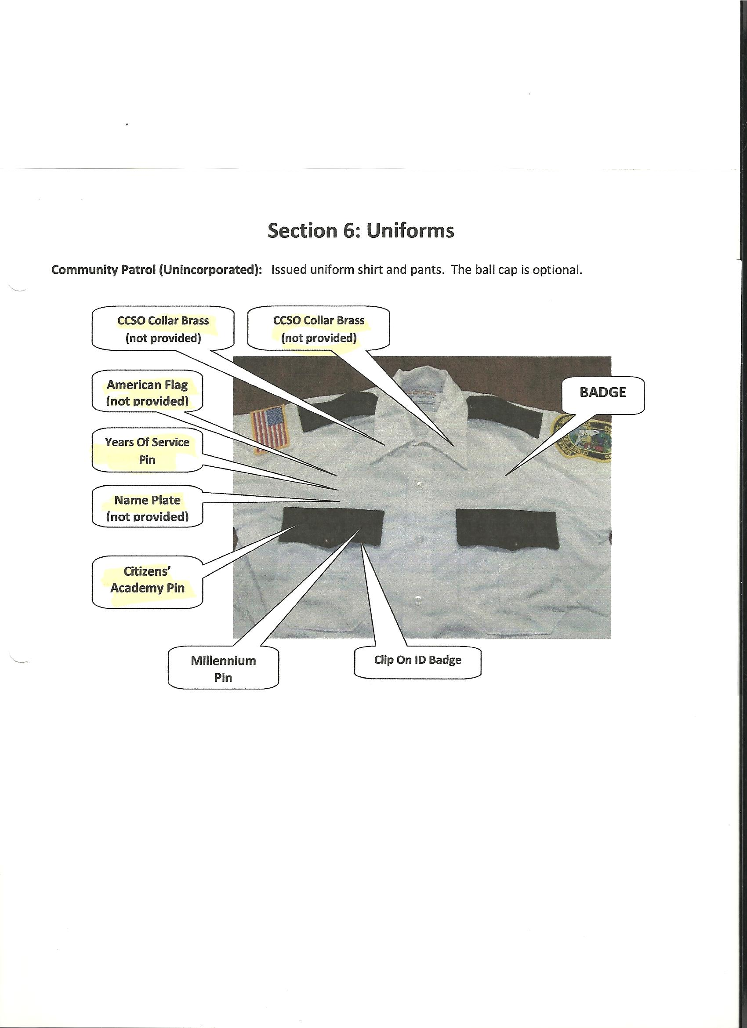
ATTACHMENT #2
CCSO CRIME MAPPING
(Excerpt from CCSO Volunteer Unit Rules & Procedures Handbook)

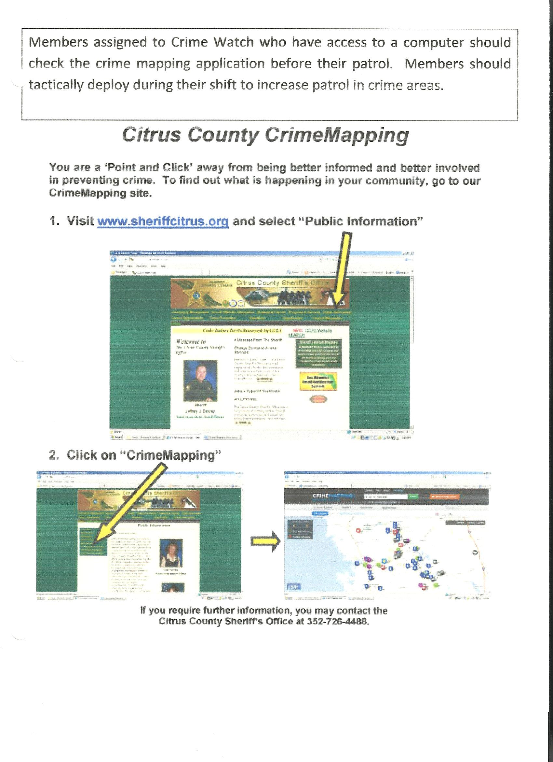
ATTACHMENT #2
CCSO CRIME MAPPING (Continued)
(Excerpt from CCSO Volunteer Unit Rules & Procedures Handbook)

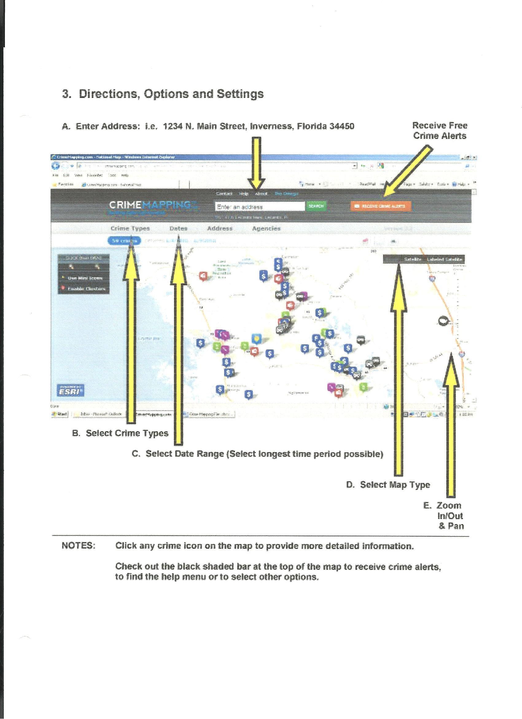
ATTACHMENT #3
PHONETIC ALPHABET

A = ALPHA J = JULIET S = SIERRA
B = BRAVO K = KILO T = TANGO
C = CHARLIE L = LIMA U = UNIFORM
D = DELTA M = MIKE V = VICTOR
E = ECHO N = NOVEMBER W = WHISKEY
F = FOXTROT O = OSCAR X = X-RAY
G = GULF P = PAPA Y = YANKEE
H = HOTEL Q = QUEBEC Z = ZULU
I = INDIA R = ROMEO

